

**System Requirement Specification**

**< Library Management System - LiMS>**

**GROUP 2_BA06**

Security Classification: **Confidential**

Approval Page

|  |  |  |  |  |
| --- | --- | --- | --- | --- |
|  | | | | |
| **Decision** | Approved  Rejected |  |  |
| Name: |  |  |  |
| Signature/Date: |  |  |  |

Revision History

|  |  |  |  |
| --- | --- | --- | --- |
| Date | Version | Author | Change Description |
| 08/08/2022 | 0.1 | Group 2 | First Creation |
| 09/08/2022 | 0.2 | Group 2 | Update the Introduction, Flowchart, 2 Swim lanes |
| 10/08/2022 | 0.3 | Group 2 | Create 2 Use Case Specifications |
| 12/08/2022 | 0.4 | Group 2 | Update Use Case Diagram  Update Wireframes of 2 Swim lanes |
| 15/08/2022 | 0.5 | Group 2 | Update Wireframes of 2 Swim lanes |
| 17/08/2022 | 0.6 | Group 2 | Create UC01 Screen Description  Create UC02 Screen Description |
| 19/08/2022 | 0.7 | Group 2 | Update the Introduction, Flowchart, 2 Swim lanes  Update Use Case Specifications: UC01  Remove Use Case Specifications: UC02  Update the Wireframes of Swim lane: Create Borrow Book Request  Remove the Wireframe of Swim lane: Create Purchase Request  Update UC01 Screen Description |
| 23/08 | 0.8 | Group 2 | Update Business Rule, Screen Description, Wireframe, Mock-up |
|  |  |  |  |
|  |  |  |  |

Table of Contents

1. Introduction 4

1.1 Purpose 4

1.2 Glossary and Abbreviations 5

1.3 Document Referenced 6

1.4 Instructions for Reading Documents 6

2. High Level Requirements 7

2.1 High Level Business Process 7

2.2 Entity Relationship Diagram 9

2.3 Use Case Diagram 10

2.4 Actor 11

2.5 Use Case Catalogue 11

2.6 Site Map 11

3. Use Case Specifications 12

3.1 UC01 <Name of Use Case> 12

3.1.1 Overview. 12

3.1.2 Activity Flow 12

3.1.3 Flow of Events 12

3.1.4 Mock-up Screen 13

3.1.5 Screen Description 20

3.1.6 Business Rules 34

3.2 UC2: Approve/Reject Approval Request 34

3.2.1 Overview 34

3.2.2 Activity Flow 34

3.2.3 Flow of Events 35

3.2.4 Mock-up Screen 37

3.2.5 Screen Description 42

3.2.6 Business Rules 44

4. Appendices 45

4.1 Message List 45

4.2 Email List 45

# Introduction

The Software Requirement Specifications will:

* Define the scope of business objectives, business functions, and organizational units covered,
* Identify the business processes that the solution must facilitate,
* Facilitate a common understanding of what the functional requirements are for all parties involved,
* Establish a basis for defining the acceptance tests for the solution to confirm that what is delivered meets requirements.

The purpose of the document is to collect and analyse all assorted ideas that have come up to define the system, its requirements with respect to consumers. Also, we shall predict and sort out how we hope this product will be used in order to gain a better understanding of the project, outline concepts that may be developed later, and document ideas that are being considered, but may be discarded as the product develops.

## Customer Overview

* **Introduction to Cambridge1 College**

Cambridge1 College is one of the biggest colleges located in Hanoi City. Beside the number of 2500-3000 undergraduate and postgraduate students, the College often welcomes about 800-1000 new students each year. The school is famous for high quality education and training with a team of highly qualified lecturers. This is also the place where several researches were conducted and thousands of research articles and journal were written. Therefore, the College has a huge library with thousands of books of all kinds

* **Customer’s Difficulty Evaluation**

Currently, Cambridge1 College owns about 4,000 books borrowed by more than 3,500 students and lectures. All of these books are being stored in their library and managed by 4 librarians together with 1 library manager who is also in charge of considering and approving request for purchasing new books if needed. Book information is stored in computer as excel files. All processes related to the library management are carried out manually by the librarians, which leads to a huge document workload and mistakes and information differences. Together with the increasing number of new readers (including new students and new lecturers) each year, the College wants to build an online library management system so that they can change all offline management activities to an online system, to perform better and faster work, meeting new requirements of the school, students and lecturers.

## Project Overview

* **Purpose**
* This project is aimed at developing an online Library Management System (LiMS) for Cambridge1 College so that they can change all offline management activities to an online system.
* A person should be able to
  + login to the system through the first page of the application
  + change the password after logging into the system
  + view the status of the books/journals borrowed/reserved by him and the respective due dates and other relevant details
  + search for a particular book/journal based on the name of the book/name of the author/subject and also list for books/journals based on the name of the author/subject.
  + reserve a particular book/journal borrowed by others currently
  + cancel the reservation made earlier for a particular book/journal
  + view who has borrowed a particular book/journal
  + view when is the due date for the same
  + place requests for purchasing new books to the library, by giving details about the name of the book, name of the author, publisher.
  + get help about the LiMS on how to use the different features of the system
* As soon as a reservation is made for a particular book, an automatic mail should be sent to the person who made the reservation about the details. Then, a mail should be sent to people who are having the book currently, stating a reservation has been made on that book.
* Automatic mails should be sent to the users about the expiry of due dates for the books/journals borrowed by them. An advance notification (say, 4 days before the expiry of the due date) should be sent as well.
* The librarian should be able to (2 – 3 use cases)
  + add new books/journals or remove some books from the inventory
  + add new users to the system
  + view the purchase requests for new books and be able to approve/reject the same
* There is a function to review the book which student has read.
* **Processes**

LiMS will cover the following processes:

* Log in Process
* User Management Process
* Purchase Request Management Process
* Reservation Request Management Process
* Borrowing Book Process
* Support Guide Process
* **Versions**

During the project implementation, there will be 3 versions released:

* Closed Beta Test Version 1.0 (Login, Logout, Reset Password, Borrow Book, Create User, See Book information
* Closed Beta Test Version 1.1 (Make purchase request, Automatic email, Access support Guide)
* Official Version (Full features)

## Functional & Non-functional Requirements

* **Functional Requirements**

*Functional requirements for Students/Lecturers as below:*

* Log in
* Log out
* Change password
* View account information
* Update account information
* Recover password
* Search and view book’s information
* View book’s status
* Create Borrow Request
* Cancel Borrow Request
* Create Reservation Request
* Cancel Reservation Request
* Create Purchase Request
* Cancel Purchase Request
* Create Book Review
* Recover password
* View user’s borrow list
* View Support Guide

*Functional requirements for Librarians and Library Manager as below:*

* Log in
* Log out
* Reset account
* Add Book
* Remove Book
* Update Book’s information
* View Borrow List
* View Reservation Request List
* View Purchase Request List
* Create new user
* Search and view user’s information
* Delete user
* View Book Review
* View and Update Support Guide

*Functional requirements for System as below:*

* Update book status
* Send auto emails (confirm request, confirm update/cancel, notify, warning)
* Update borrow list
* Update purchase request list
* Update reservation list
* **Non-functional Requirements**

Non-functional requirements for the System as below:

* LiMS is an Intranet based website that can be accessed throughout the campus.
* LiMS is one integrated system that contains both the user component and the admin component.
* LiMS can run on devices provided with Android 6.0 and more, IOS 8 and more, Macbook, Window and Linux, not Smart Watch.

## Glossary and Abbreviations

|  |  |
| --- | --- |
| Acronym | Reference |
| SRS | System Requirement Specification |
| UC | Use Case |
| BR | Business Rules |
| CBR | Common Business Rules |
| ET | Email Template |
| N/A | Not Applicable or Not Available |
| MSG | Message |
| [Field] | Convention for mentioning a field |
| <<Field>> | Convention for value of this field, specifically use in the context of Email Template |
| “Text Value” | Convention for mentioning a value |
| <Value> | Convention for mentioning special value, i.e. <Today>, <Current User> |
| TBU | To be Updated |
| NRF | National Research Foundation |
| OOE | Other Operating Expenditure |
| LiMS | The Library Management System |

## Document Referenced

|  |  |
| --- | --- |
| Attachment | Document Name / Title |
|  | High Level Requirement Slide |
|  | High Level Wireframes |

## Instructions for Reading Documents

* Customer and End User: Support Guide, User Functions, User Rights
* Business Analyst:

+ High Level Requirement.

+ Organization Chart

+ Use Case Model

+ Rules

* Developer: Use Case Requirement
* Tester

+ Test Plan

+ Test Scenarios.

# High Level Requirements

## High Level Business Process <System Flowchart>

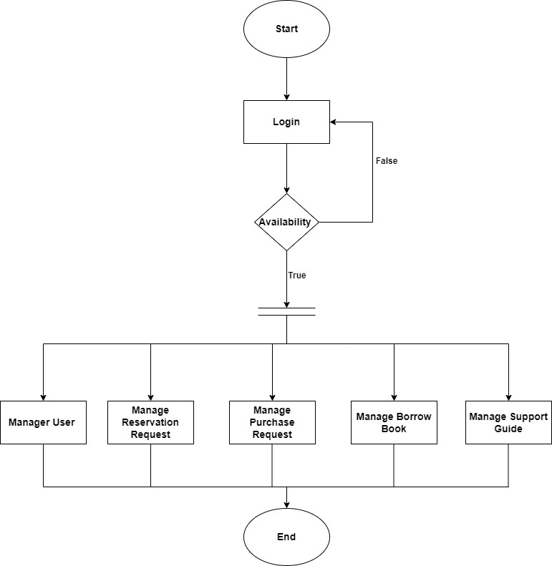

**<Swim-lane diagram>** 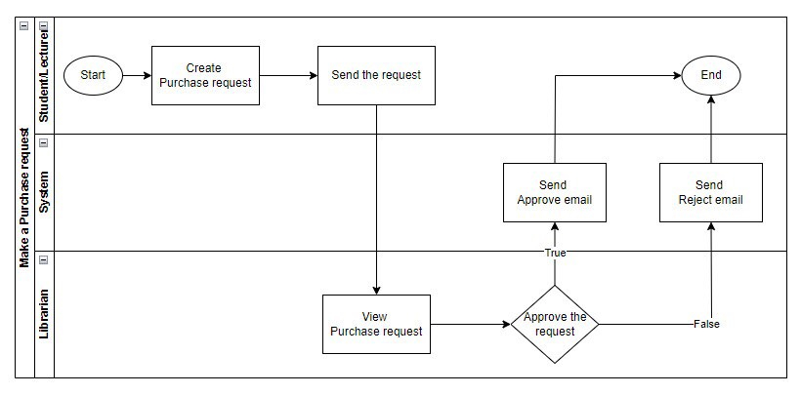

**<Process: Manage Borrow Book**

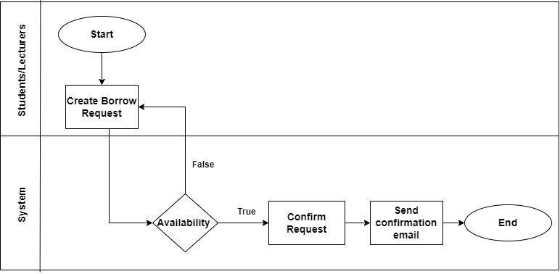

## Entity Relationship Diagram

## Use Case Diagram

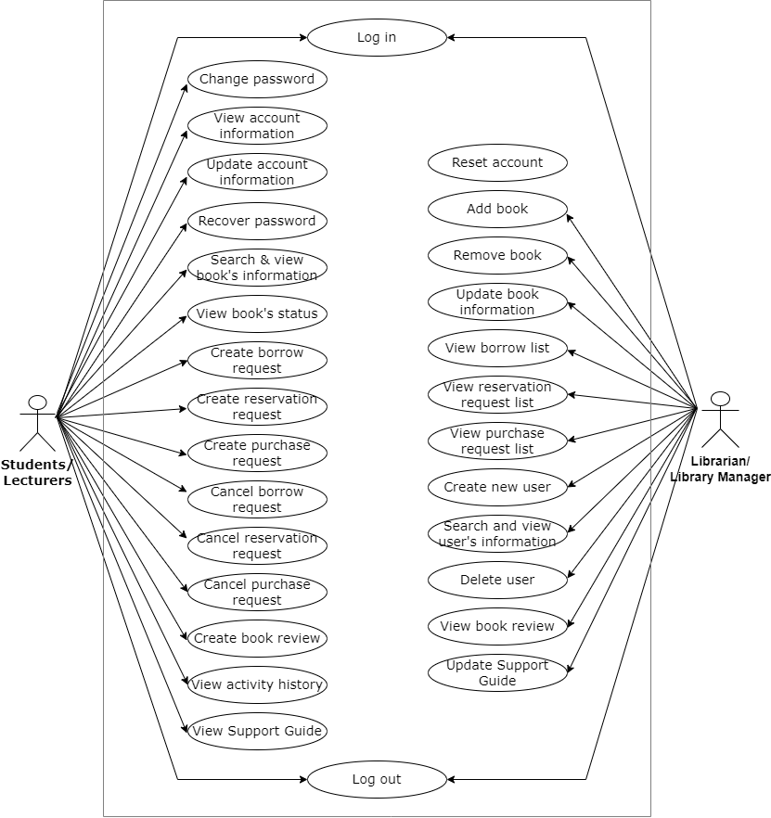

## Actor

|  |  |
| --- | --- |
| Actors | Description |
| Students | All students studying at the college including: undergraduates and post-graduate  Each student has an account to log in the system as a user. |
| Lecturers | Lecturers of all departments managed by the College  Each lecturer has an account to log in the system as a user. |
| Library Manager | The person who is in charge of dealing with all issues and making decisions related to the library. The Library Manager has an account to log in the system as an admin. |
| Librarian | The person who works at the library and carries out all processes to operate it.  Each librarian has an account to log in the system as an admin. |

## Use Case Catalogue

|  |  |  |
| --- | --- | --- |
| UC ID | UC Name | Description |
| UC01 | Log in | Allow actors access the system |
| UC02 | Log out | Allow actors end the session and exits the system. |
| UC03 | Change password | Allow students/lecturers to change their account password after logging into the system. |
| UC04 | View account information | Allow students/lecturers to view their detailed personal information |
| UC05 | Update account information | Allow students/lecturers to edit/change some of their personal information saved in their account, including phone number, current address, and email address. |
| UC06 | Recover password | Allow students/lecturers to recover the account password they forgot. |
| UC07 | Search & view book’s information | Allow students/lecturers to search for the book they need and view some detailed information about the book including book name, book category, book ID, author, ratings, introduction, publisher and actions related to the book. |
| UC08 | View book’s status | Allow students/lecturers to see book’s status including available, being borrowed, not available, number of each book, status of book (new/old, no cover page, lack some pages) |
| UC09 | Create borrow request | Allow students/lecturers to search and make request to borrow the book they want. They must to log in first. |
| UC10 | Create reservation request | Allow students/lecturers to reserve a book so that he/she can borrow it after book is returned. |
| UC11 | Create purchase request | Allow students/lecturers to make purchase request for the book(s) which the library does not have. They must log in first. |
| UC12 | Cancel borrow request | Allow students/lecturers to cancel the borrow request for the book they want within 24 hours since the request creation time. |
| UC13 | Cancel reservation request | Allow students/lecturers to cancel the reservation request for the book they want within 24 hours since the request creation time. |
| UC14 | Cancel purchase request | Allow students/lecturers to cancel the purchase request for the book they want but the library does not have within 24 hours since the request creation time. |
| UC15 | Create book review | Allow students/lecturers to write review for a book they have read and submit to the system. |
| UC16 | View activity history | Allow students/lecturers to see detailed information about activities they performed on the system. |
| UC17 | View Support Guide | Students/lecturers can refer to this UC when they get problems with system’s features. |
| UC18 | Reset account | Allow librarians/library manager to reset an existing account to support students/lecturers when they cannot handle the problem by changing password, recovering forgotten password, or referring the support guide. |
| UC19 | Add book | Allow librarians/library manager to add new book to the system to get it ready for students/lecturers to borrow and use. |
| UC20 | Remove book | Allow librarians/library manager to delete a book which does not exist in the system anymore. |
| UC21 | Update book information | Allow librarians/library manager to update information of a book when there is any mistakes, changes or updates. |
| UC22 | View borrow list | Allow librarians/library manager to see all borrow request list and their status. |
| UC23 | View reservation request list | Allow librarians/library manager to see all reservation request list and their status. |
| UC24 | View purchase request list | Allow librarians/library manager to see all purchase request list and their status. |
| UC25 | Create new user | Allow librarians/library manager to add new user into the system and export the account information to send to new students/lecturers. |
| UC26 | Search and view user’s information | Allow librarians/library manager to search and view information of any account. |
| UC27 | Delete user | Allow librarians/library manager to remove current user out of the system. |
| UC28 | View book review | Allow librarians/library manager to view book review written by students/lecturers. |
| UC29 | Update Support Guide | Allow librarians/library manager to update the support guide (FAQ) whenever there is any changes or updates. |

## Site Map

<The site map describes the way for navigating through the system. (Optional)>

# Use Case Specifications

This section covers the system’s functional requirements which details what the system must do in terms of input, behavior and the expected output. It elicits the interaction between the actor(s) and the system, the system’s behavior and the results of their interactions.

## UC01 <Log in>

## UC02 <Log out>

## UC03 <Change password>

## UC04 <View account information>

## UC05 <Update account information>

## UC06 <Recover password>

## UC07 <Search & View book’s information>

## UC08 <View book’s status>

## UC09 <Create Borrow Request>

### Overview.

|  |  |
| --- | --- |
| ID and Name | UC09: Create Borrow Request |
| Description | Allow students/lecturers to search and make request to borrow the book they want. They must to log in first. |
| Actor | Students, Lecturers |
| Trigger | Click to “Borrow Book” button on book details page |
| Pre-condition | The book exist and in available status in the system. |
| Post-condition | System shows "Submitted Request Successfully" display  Actor receives notification email with attached form. |

### Activity Flow

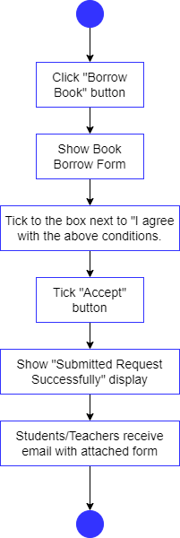

### Flow of Events

#### Basic Flow

|  |  |
| --- | --- |
| Step | Description |
|  | Students/Lecturers Click to “Borrow Book” button on book details page. |
|  | System shows Book Borrow Form. |
|  | Students/Lecturers tick to the check box next to “I agree with the above conditions.” |
|  | Students/Lecturers click on “Accept” button |
|  | System shows "Submitted Request Successfully" display. |
|  | System sends email with attached form to students/lecturers. |

#### Alternative Flow - <Click “Cancel” button>

| Step | Description |
| --- | --- |
|  | At step 4, when students/lecturers want to check the book information again before deciding to borrow the book, they click "Cancel" button |
|  | Repeat from step 1 |

#### Exceptional Flow - < Unstable network connection>

|  |  |
| --- | --- |
| Step | Description |
|  | At step 4, when students/lecturers click on "Accept" button, the network connection is unstable, system shows error "No internet connection. Please check your network connectivity and try again" |
|  | Students/lecturers click “OK” button and repeat from step 1 |

### Mock-up Screen

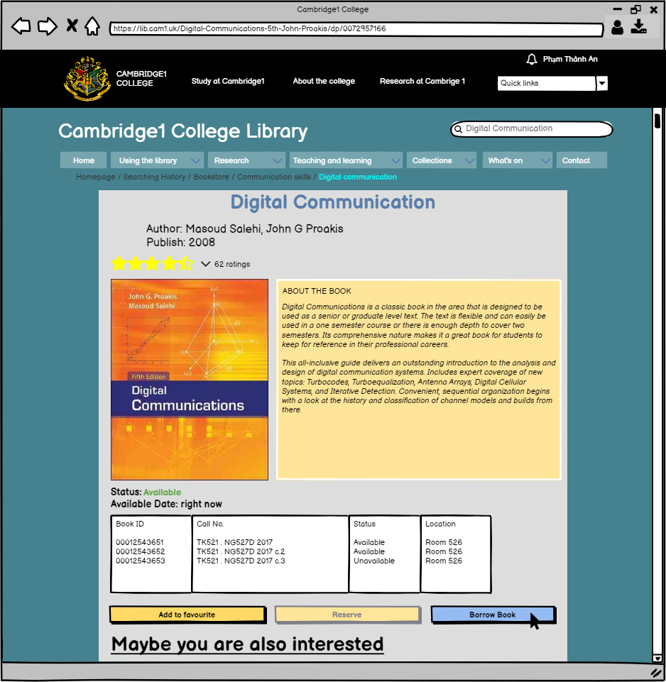

UC09.1: Click “Borrow Book” button

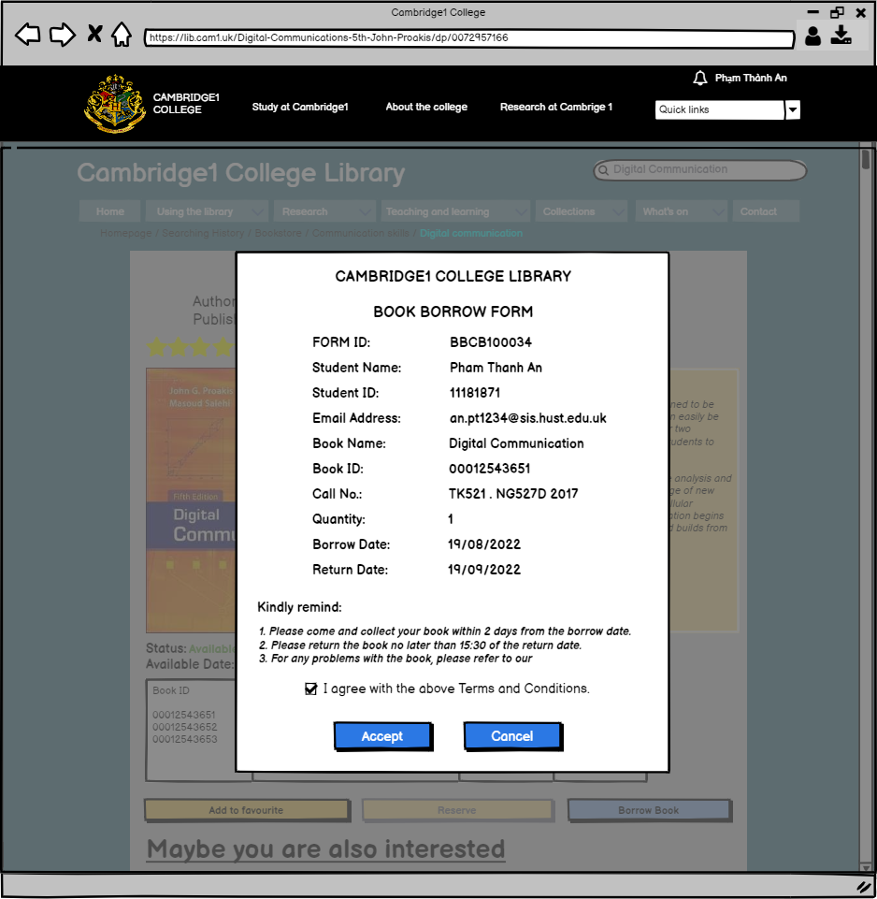

UC09.2: Borrow Request Form

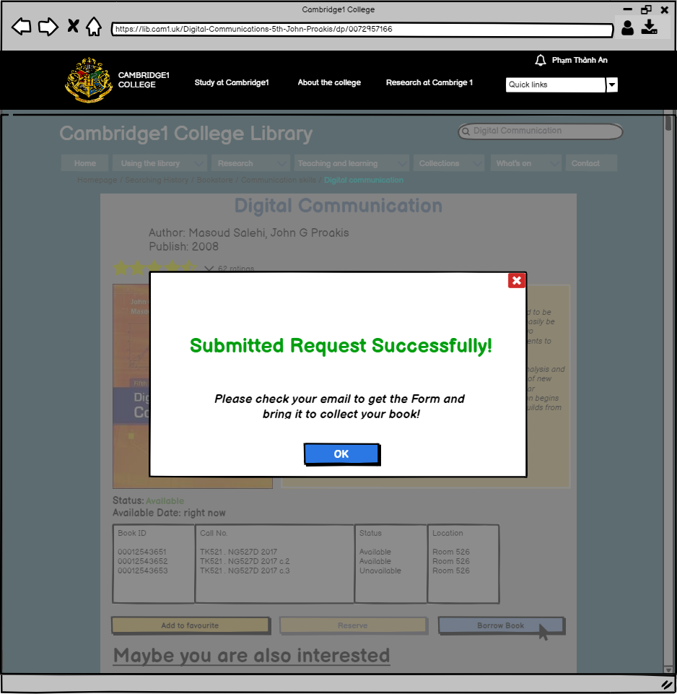

UC09.3: Submitted Request Successfully!

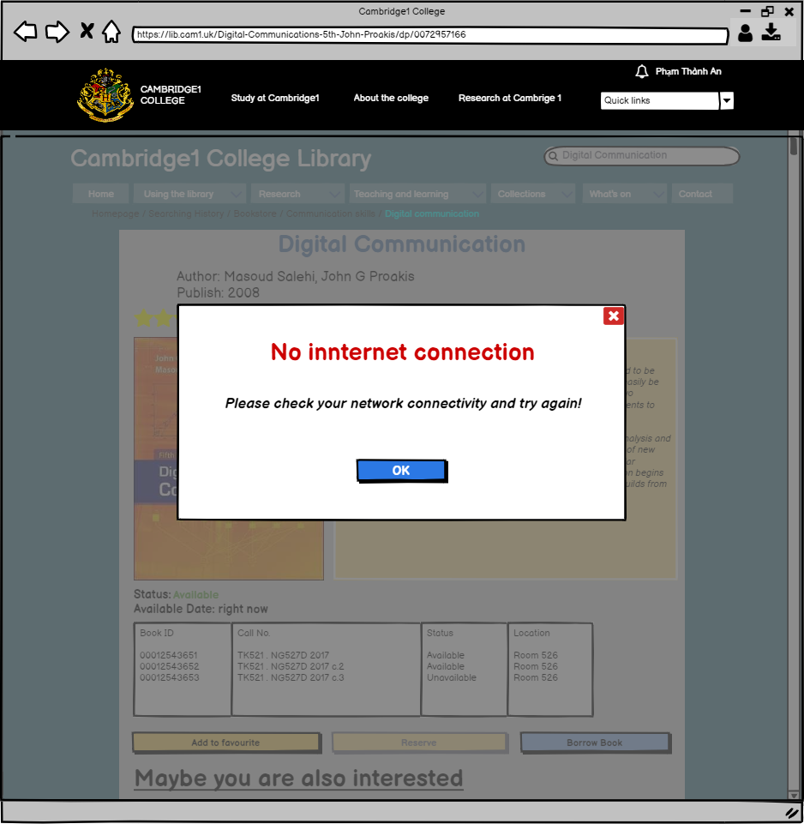

UC09.4: No internet connection

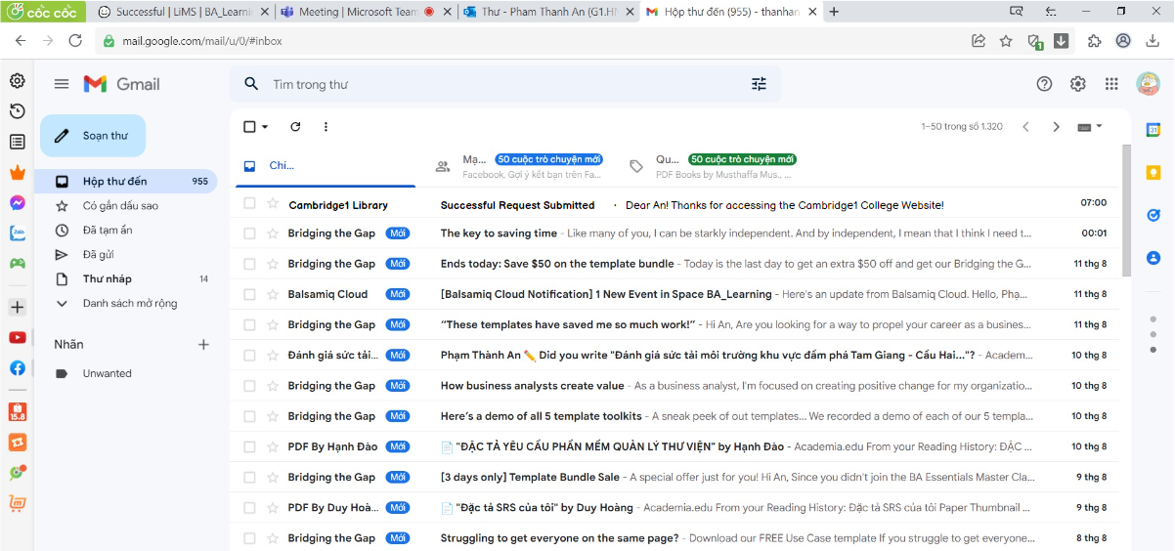

UC09.5: Confirmation email

|  |  |
| --- | --- |
|  |  |

### Screen Description

**UC09.1**

| REF | Field Name | Control  Type | Data Type | Default Value | Mandatory | Editable | Description |
| --- | --- | --- | --- | --- | --- | --- | --- |
| 1 | Book name | Label | Text | The chosen book's name | N/A | N | Show the name of the book students/lecturers want to borrow |
| 2 | Author | Label | Text | The chosen book's author | N/A | N | Show the name of the book's author that students/lecturers want to borrow  Author name is auto generated from the database of books in the library ABC1. (table of book >>”author” field) |
| 3 | Publish | Label | Text | The chosen book's publish | N/A | N | Show the name of the book publisher students/lecturers want to borrow  Publisher name is auto generated from the database of books in the library ABC1. (table of book >>”author” field) |
| 4 | Book ID table | Data grid | Text | ID of the current book | N/A | N | Represent the book ID  This ID is auto generated from the database of books in the library. (table of book >>”Book ID” field) |
| 5 | Call No. table | Data grid | Text | Call No. of the current book | N/A | N | Represent the book’s Call no.  This Call no. is auto generated from the database of books in the library. (table of book >> “Call no.” field) |
| 6 | Status table | Text | Text | N/A | N/A | N | Represent the book’s status  This Status is auto generated from the database of books in the library. (table of book >> “Status” field) |
| 7 | Location | Text | Text | N/A | N/A | N | Represent the book’s status  This location is auto generated from the database of books in the library. (table of book >> “Location” field) |
| 8 | Rating Star | Icon | Icon | Average rating | N/A | N | Show the rating of book |
| 9 | About the book | Text | Text | Book’s overview | N/A | N | Show a summary of the book's content so that users can imagine whether the book's content is attractive or suitable for their need |
| 10 | Add to favourite | Button | Text | N/A | N/A | N | Allow students/lecturers to add the current book to their favourite list. |
| 11 | Reserve | Button | Text | N/A | N/A | N | When the book is unavailable to borrow, student can reserve book and pick up when the book is available.  When the book is available, this button is disable. |
| 12 | Borrow Book | Button | Text | N/A | N/A | N | Allow user to create borrow request  Activate navigation to Borrow Book Form when the book is available to borrow.  When book is unavailable to borrow, this button is disable. |
| 13 | Maybe you are also interested | Link | Text | N/A | N/A | N | Access the page with many books on the same topic with the book the user searches when the user clicks on it |
| 14 | Book Image | Image | Image | N/A | N/A | N | Show the book's performance |
| 15 | Status | Text | Text | Available/Unavailable | N/A | Y | Show the overall state of the book. The information is taken from the status of all of books |
| 16 | Available date | Text | Text | The date that the book is available to borrow | N/A | Y | When the book is borrowed, system show the latest date |

**UC09.2**

| REF | Field Name | Control  Type | Data Type | Default Value | Mandatory | Editable | Description |
| --- | --- | --- | --- | --- | --- | --- | --- |
| 1 | CAMBRIDGE1 COLLEGE LIBRARY | Label | Text | N/A | N/A | N | Indicate the name of the library |
| 2 | BOOK BORROW FORM | Label | Text | N/A | N/A | N | Indicate the name of the form |
| 3 | FORM ID | Text | Text | N/A | N/A | N | Indicate the ID no. of the Book Borrow Form.  The Form ID is auto generated by the System. |
| 4 | Student Name | Text | Text | Name of the student logging in | N/A | N | Represent the student’s name  This name is the same as the one in student’s profile.  Name is written with spaces between words and without tones.  *E.g: Pham Thanh An*  Trigger UC07 “Search & view book’s information” and Click “Borrow Book” Button, please refer to the document “<XXX>” for more details. |
| 5 | Student ID | Text | Numeric | ID of the student logging in | N/A | N | Represent the student’s ID  This ID is the same as the ID in student’s profile.  *E.g: 11181871*  Trigger UC07 “Search & view book’s information” and Click “Borrow Book” Button, please refer to the document “<XXX>” for more details. |
| 6 | Email address | Text | Text | Email address of the student logging in | N/A | N | Represent the student’s email address  This email address is the same as the one in student’s profile.  This email address must be the school email  *E.g: …..@sis.hust.edu.uk*  Trigger UC07 “Search & view book’s information” and Click “Borrow Book” Button, please refer to the document “<XXX>” for more details. |
| 7 | Book Name | Text | Text | Name of the book the student want to make borrow request | N/A | N | Represent the name of the book that student want to make the borrow request  The name must be exactly the same as the name of the document.  *E.g: Digital Communication*  Trigger UC07 “Search & view book’s information” and Click “Borrow Book” Button, please refer to the document “<XXX>” for more details. |
| 8 | Book ID | Text | Text | Auto generated | N/A | N | Represent the book’s barcode.  This barcode is auto generated from the database of books in the library. (Database code…) |
| 9 | Call No. | Text | Numeric | N/A | N/A | N | Represents the number of the bookshelf containing that book  This Call No. is auto generated from the database of books in the library. (Database code…) |
| 10 | Quantity | Text | Numeric | 1 | N/A | N | Represent number of books the student can borrow. |
| 11 | Borrow date | Text | Text | Current date | N/A | N | Represent the date student begins borrowing books  Date format: đ/mm/yyyy |
| 12 | Return date | Text | Text | Auto generated | N/A | N | Represent the date student has to return the book  Return date is 30 days after the borrow date.  Date format: dd/mm/yyyy |
| 13 | Kindly remind | Label | Text | Some rules of the library | N/A | N | This is to remind student about borrowing rules and regulations of the library. |
| 14 | Terms and Conditions | Link | Text | Terms and Conditions | N/A | N | Activate navigation to Terms and Conditions of the Library |
| 15 | Checkbox | Checkbox | Checkbox | I agree with the above Terms and Conditions. | N/A | N | User clicks here to show he/she agrees with Terms and Conditions. |
| 16 | Accept | Button | Text | Accept | N/A | N | User clicks here to finish the book request.  Activate navigation to “submitted request successfully” display.  Disable if user does not tick the checkbox. |
| 17 | Cancel | Button | Text | Cancel | N/A | N | Activate navigation to book detail information page. |

**UC09.3**

| REF | Field Name | Control  Type | Data Type | Default Value | Mandatory | Editable | Description |
| --- | --- | --- | --- | --- | --- | --- | --- |
| 1 | Submitted Form | Label | Text | Submitted Request Successfully! | N/A | N | Inform that the request is submitted successfully. The data is stored.  Trigger: Students/Lecturers click “Accept” button. |
| 2 | Please check your email to get the Form and bring it to collect your book! | Text | Text | Please check your email to get the Form and bring it to collect your book! | N/A | N | This is to remind request creator. |
| 3 | Button | Button | Text | OK | N/A | N | User click "OK" to close the submitted form |
| 4 | Button | Button | N/A | X | N/A | N | User click "OK" to close the submitted form |

**UC09.4**

| REF | Field Name | Control  Type | Data Type | Default Value | Mandatory | Editable | Description |
| --- | --- | --- | --- | --- | --- | --- | --- |
| 1 | No internet connection | Label | Text | No internet connection | N/A | N | To warning students/lecturers about the error |
| 2 | Please check your network connectivity and try again! | Text | Text | Please check your network connectivity and try again! | N/A | N | To suggest solution for students/lecturers to continue the flow. |
| 3 | OK | Button | Text | OK | N/A | N | Activate navigation to Book detail information page. |

### Business Rules

|  |  |
| --- | --- |
| Business Rule ID | Business Rule Description |
| BRL-01-01 | The loan period is 1 month |
| BRL-01-02 | The students/lecturers information is from library's database |
| BRL-01-03 | Return the book no later than 15:30 of the return date |

# Appendices

## Message List

## Email List